Share your ideas for your neighbourhood facilities and parks
Waikato District Council is examining its strategies and plans for the Council-owned public spaces and community facilities that you use, whether you are playing sports, walking your dog or attending an event at your local hall.

It is running a “pre-consultation” with the community to help re-shape the Neighbourhood Parks Reserve Management Plan and the Sports Park Reserve Management Plan, and to develop a Community Facilities Strategy. Formal consultation will follow at a later date. The neighbourhood reserves and sports parks management plans were last prepared in 2015 and 2016 and need to be updated. The Community Facilities Strategy will be a guidance document that builds off your expectations about built spaces for public use including community halls, sports and leisure facilities, libraries and public toilets. It will guide strategy around investment and levels of service.

The Council wants to know what you like or dislike about your local facilities, and any ideas you have about the future of the amenities in your area. You can either use the interactive map on the Council’s website, or download a submission form to write down your ideas and then email the completed form to reserve.planning@waidc.govt.nz.

The closing date for submissions is Friday 6 September. For more information go to www.waikatodistrict.govt.nz/say-it.

Applications are open for the Creative Communities Fund – closing soon
The Creative Communities Fund is aimed at supporting art activities that celebrate the uniqueness of the Waikato district, its cultural traditions and diversity, including Toi Māori. Its goal is to increase participation from the local community in the arts sector and encourage young people to participate in local arts. ‘Arts’ is broadly defined to mean all forms of creative and interpretative expression. Individuals and groups can apply for projects aimed to benefit local communities that will take place within a year of funding being granted. The deadline for applications is 5pm Thursday 5 September. For more information go to www.waikatodistrict.govt.nz/funding.

Slow Fashion ‘SEWtember’ – local events
More than 533 tonnes of fabric waste end up in our district’s landfill each year – nearly half a kilogram of waste fabric per household per week - so the Council is on a mission to combat the negative effects of fast fashion this ‘SEWtember’. We’ve partnered with community groups and volunteers to run a range of events across the district to help you love, mend and alter the clothes you already have with a view to minimise our landfill waste.

‘Sewtember’ events in Tamahere-Woodlands Ward
In Tamahere-Woodlands Ward you can get tips on how to develop your own sustainable style at an event at Gordonton Hall on 11 September (7-9pm), join an online wardrobe tour on Sep 16 (7.30-8.30pm), or head down to Matangi Hall for a Friday night ‘Sewcial’ on 20 September (6-9pm) and get creative with repairing and refashioning. For more info and to book your place go to www.waikatodistrict.govt.nz/sewtember

SH26 roadworks – detours planned from mid-September
NZTA will be undertaking roadworks on SH26 just south of Eureka for a month starting in mid-September. A full road closure is proposed with two potential detours on local district roads:
- Detour 1: Tauwhare Rd and Platt Rd
- Detour 2: Eureka Rd, Holland Rd and Marshmeadow Rd (SH1B)

These plans are subject to change, so if you’re planning a trip to Morrinsville or further afield to an East Coast beach, watch for updates on NZTA’s website here: https://www.journeys.nzta.govt.nz/regions/waikato/roadworks

See the proposed detours on the map here:
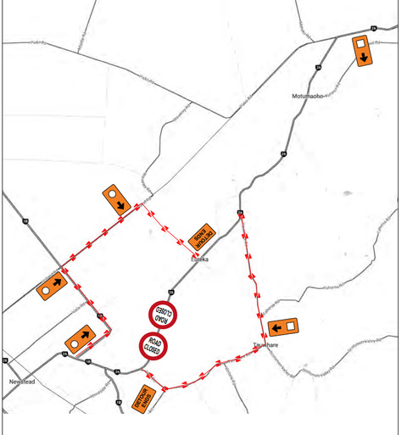

Maaori Wards
Waikato District Council has voted to retain its Maaori Wards for the next triennium, but to hold a binding referendum at the next local body elections in 2025 to determine whether Maaori Wards will be retained from 2028 onwards.

Background: Maaori represent 26% of the district’s population, and more than 15,000 Maaori in the district have chosen to be on the Maaori electoral roll. Two Maaori Wards covering half the district each were established during the district’s Referendum Review in 2021. In 2022 Cr Tilly Turner was elected to represent the Maaori community in Tai Runga Takiwaa Maaori Ward covering the southern half of the district.

